Financial Lit Name: _______________________

______________ _____________

WS Assessment

Target 5:

Expend and revenue

**I can:**

* Write, graph and interpret the expense function, the revenue function
* Identify breakeven points, and explain them in the context of the problem
* Determine a profit equation given the expends and revenue equations

**Unit 2 Math Topics:**

* Causal relationship
* Functions - domain and range
* Linear equation – slope-intercept form
* Linear regression
* Parabola – vertex and axis of symmetry
* Quadratic formula
* Scatterplots and correlation
* Spreadsheets and formulas
* Transitive property of dependence

The total expenses is the sum of the fixed and variable expenses. The **expense equation** is

E = V + F where E: total expenses, V: variable expenses, and F: fixed expenses

The income a business receives from selling its product is revenue. Revenue is the price for which each was sold times the number of products sold. The **revenue equation** is

R = pq where R: revenue, p: the price of the product, and q: the quantity of products sold

The difference obtained when expenses are subtracted from revenue is a **profit** when positive and a loss when negative. When the expenses and the revenue are equal, there is no profit or loss. This is the **breakeven** point.



Examine the graph of expense and revenue.

a. What is the breakeven point?

b. If quantity C is sold and C < A, is there

a profit or a loss? Explain.

c. If quantity D is sold and D > A, is there

a profit or a loss? Explain.

d. The y-intercept of the expense function is Z. Interpret

what the company is doing if it operates at the point (0, Z).

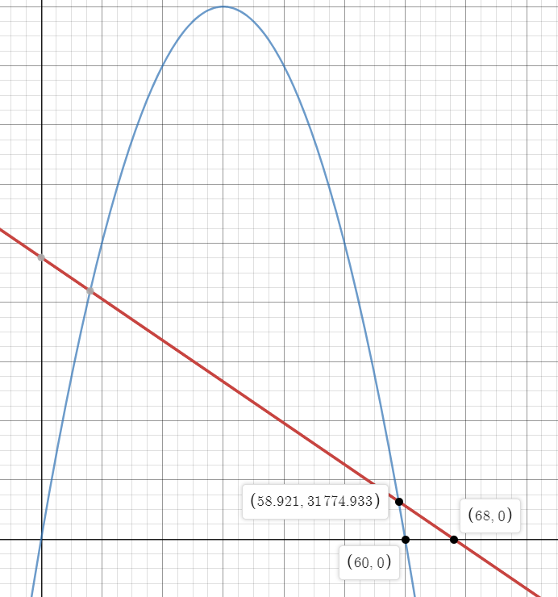A particular item in the Picasso Paints product line costs $7.00 each to manufacture. The fixed costs are $28,000. The demand function is q = -500p + 30,000 where q is the quantity the public will buy given the price, p. Write the expense function E = V + F in terms of price (p)

Write the revenue equation R = pq in terms of the price (p)

Show this graph for stamp

Orange-U-Happy is an orange-scented cleaning product that is manufactured in disposable cloth pads. Each box of 100 pads costs $5 to manufacture. The fixed costs for Orange-U-Happy are $40,000. The research development group of the company has determined the demand function to be

q = -500p + 20,000, where p is the price for each box.

Write the expense equation in terms of the demand, q.

Write the expense function in terms of the price p.

Write the revenue function in terms of the price.

Sketch a graph the revenue and expense functions in term of p. Identify the price at the breakeven points. Stamp

Many scatterplot points can be approximated by a single line that best fits the scattered points. This line



The functions intersect at the values at

which the expense and revenue functions are

equal (blue points), or the breakeven points.

The difference between expense and revenue

equals zero, which is a **zero net difference**.

Breakeven points may be found algebraically or by using a graphing. To find breakeven points algebraically, set the expense and revenue functions equal to each other.

Determine the prices at the breakeven points for the Picasso Paints product above algebraically

The expense function is E = -3,500p + 238,000, and the revenue function is R = –500p2 + 30,000p.

Determine the revenue and expense for the Picasso Paints product at the breakeven points found above



Redo this problem in google docs for stamp

<http://bit.ly/30Ro0JM>

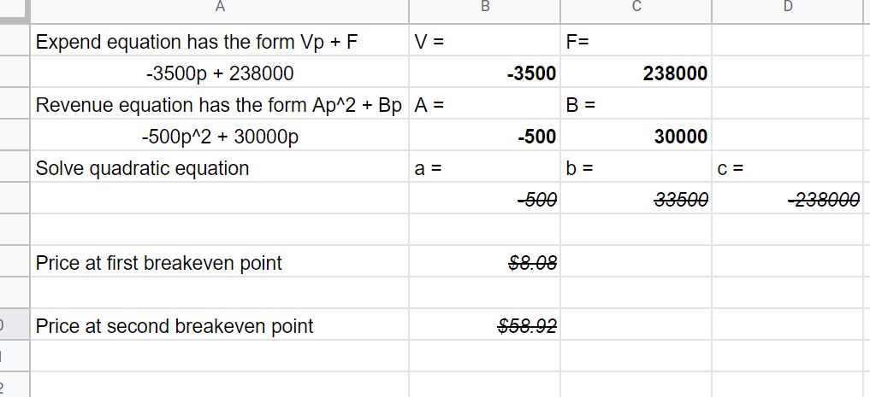

Show the answer of Orange-U-Happy in google docs for stamp



Graphically, profit is the vertical distance between the revenue and expense functions.

P = R – E

In the figure several profit line segments have been drawn for different prices. The longest segment would represent the greatest difference between revenue and expense at a given price. The greatest difference between revenue and expense denotes **maximum profit**.

Suppose that the revenue and expense functions are

R = –350p2 + 18,000p and E = –1,500p + 199,000.

Write the profit equation and find its maximum profit. Show me a proof graph for stamp

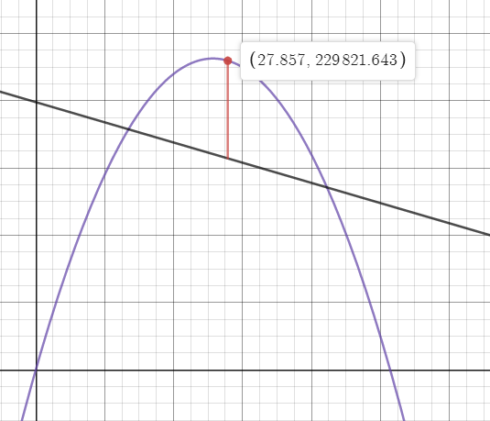

**Assessment Target 5**

**I can…** determine the profit equation given expense and revenue equations

Use this graph of revenue and expense function to answer the questions

1. Explain the significance of point (D, B).
2. Explain the significance of point (E, A).
3. Explain the significance of point (F, C).

d. Explain the significance of point (G, 0). e. Explain the significance of point (H, 0).

f. Where do you think the maximum profit might occur?

A company produces a security device known as Toejack. Toejack is a computer chip that parents attach between the toes of a child, so parents can track the child’s location at any time using an online system. The company decides to conduct a market research survey to determine the best price for the device. The variable p represents price, and q represents quantity demanded.

The points are listed as (p, q). (14, 8,200), (11, 9,100), (16, 7,750), (16, 8,300), (14, 8,900),

(17, 7,100), (13, 8,955), (11, 9,875), (11, 9,425), (18, 5,825)

Make a scatterplot of the data and write the regression equation, state the correlation. Stamp

Fixed costs are $24,500, and variable costs are $6.12 per Toejack.

Express expenses, E, as a function of p, the price

Express the revenue, R, in terms of p

Graph the expense and revenue functions. Determine the breakeven points Stamp

Express the profit, P, in terms of p. At what price p is profit maximized? Show proof graph for stamp